Q1 | Install MySQL Community Server or SQLite on your system and verify the installation by connecting to the database using the command line or a GUI tool like MySQL Workbench or DB Browser for SQLite.
Code | AIM:  To install MySQL Community Server and verify that the database is working by connecting through MySQL Workbench.  Software Used:  1. MySQL Community Server 8.x  2. MySQL Workbench  Step-by-step Procedure  - Download MySQL Community Server from the official MySQL website.  - Run the installer and choose Developer Default (or Server + Workbench).  - Complete the installation and set a password for the root user.  - Open MySQL Workbench.  - Click Local instance MySQL80 (or your local MySQL connection).  - Enter the root password and click OK.  - After the connection opens, create a new SQL tab.  - Run the verification command below.  Verification Command  SELECT VERSION();  Expected Output  MySQL server connected  8.0.xx
Output | 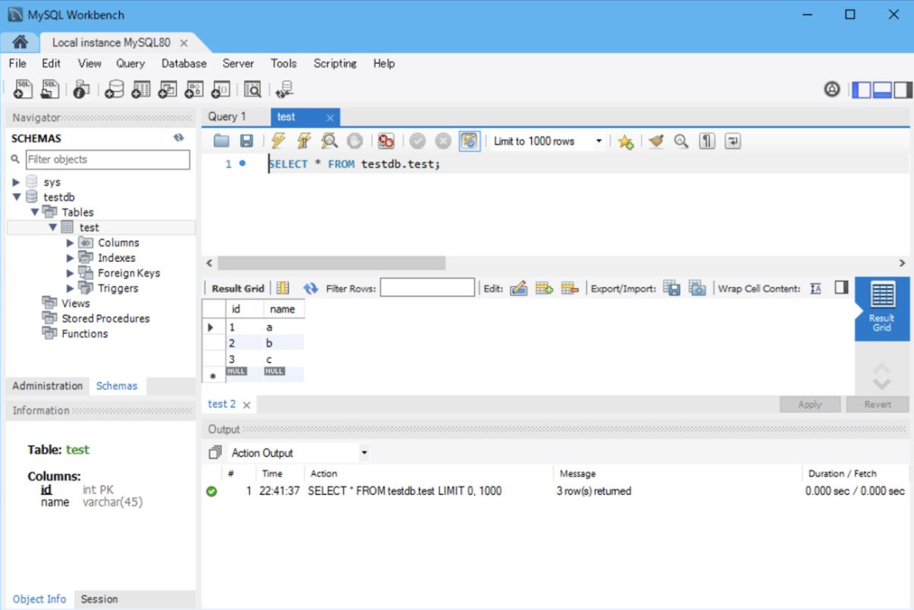

Q2 | Create a new database named 'foodie_app' to simulate a Zomato-style backend.
Code | CREATE DATABASE foodie_app;
Output | 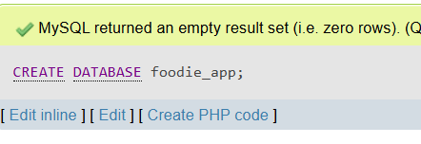

Q3 | Write a CREATE TABLE statement to define a 'restaurants' table in the 'foodie_app' database with the following columns: id (integer, primary key), name (varchar/character, max 100), cuisine (varchar/character, max 50), rating (decimal, e.g., 4.5), and location (varchar/character, max 100).
Code | CREATE TABLE restaurants( id int AUTO_INCREMENT, name varchar(50), cuisine varchar(50), rating decimal(2,1), location varchar(50), PRIMARY KEY(id) );
Output | 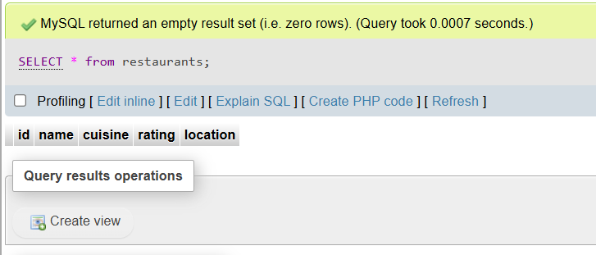

Q4 | Design and create a 'users' table for a Flipkart-style app with columns: user_id (primary key), username, email, phone_number, and created_at (date/time). Pick appropriate data types for each column.<br><br><em><strong>Hint:</strong> Think about which columns should be unique and which data types best fit email and phone numbers.</em>
Code | CREATE TABLE users ( user_id INT AUTO_INCREMENT, username VARCHAR(50) UNIQUE, email VARCHAR(100) UNIQUE, phone_number VARCHAR(15), created_at DATETIME, PRIMARY KEY(user_id) );
Output | 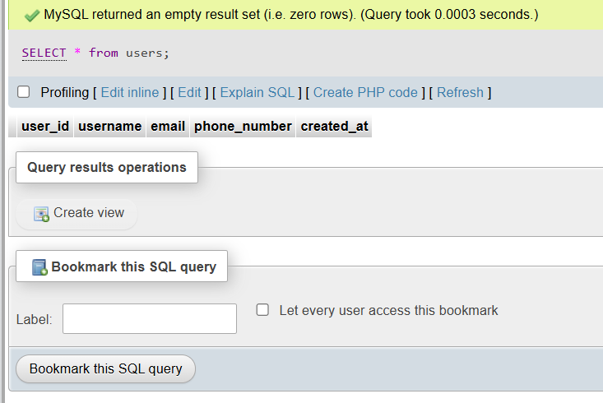

Q5 | Intentionally make a mistake in your CREATE TABLE statement (such as missing a comma or using an unsupported data type), run it, and then fix the error based on the message you receive.<br><br><em><strong>Hint:</strong> Take a screenshot of the error and the corrected SQL statement for your records.</em>
Code | Error query:  CREATE TABLE demo (  id INT PRIMARY KEY  name VARCHAR(50)  );  Correct Query:  CREATE TABLE demo ( id INT PRIMARY KEY, name VARCHAR(50) );
Output | 